**Website Designing and Development**

Summer Internship Report

submitted in partial fulfillment of the requirement for the degree of

Bachelor of Technology

In

Computer Science & Engineering

by

**MOHIT KUMAR – 00496307222**



Maharaja Surajmal Institute of Technology

(Affiliated to Guru Gobind Singh Indraprastha University)

Janakpuri, New Delhi-58

November 2023

**CERTIFICATE**

This is to certify that MOHIT KUMAR has successfully completed a Summer Internship at VITAL VISHWA PUBLICATIONS Pvt. Ltd. from 1 August 2023 to 4 September 2023. During the internship, he actively participated in Website Design and Development.

MOHIT KUMAR 00496307222

Signature

**Certificate (From the organization)**

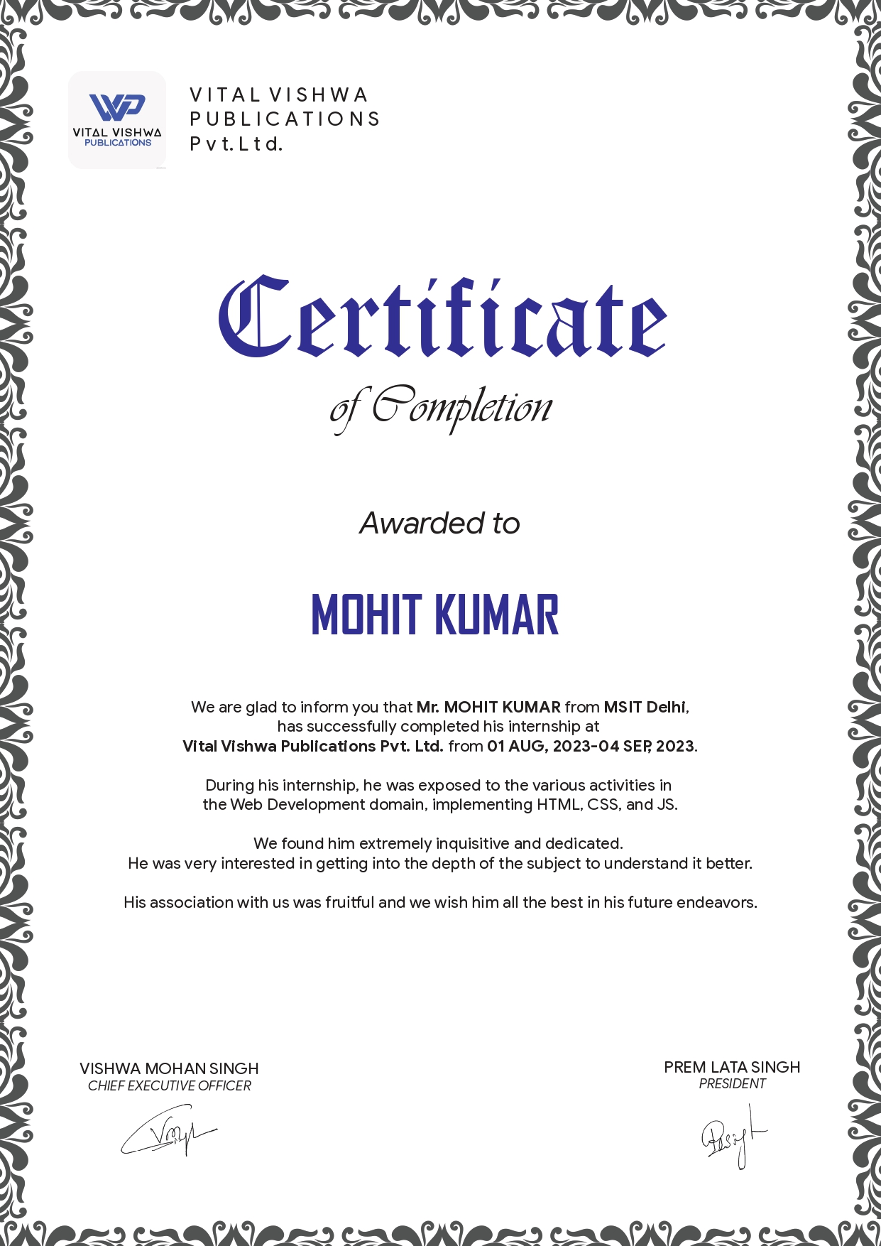

**Acknowledgement**

A research work owes its success from commencement to completion, to the people in love with researchers at various stages. Let me on this page express my gratitude to all those who helped us in various stages of this study. First, I would like to express my sincere gratitude to **Dr. Nishtha Jatana** (HOD, Department of Computer Science and Engineering, Maharaja Surajmal Institute of Technology, New Delhi) for allowing me to undergo the summer training of 5 Weeks.

I am grateful to our guide **Kanishq Singh Vishwa**, for the help provided in completion of the project, which was assigned to me. Without his friendly help and guidance it was difficult to develop this project.

I am also thankful to **Ms. Gunjan Beniwal** for her true help, inspiration and for helping me to prepare for the final report and presentation.Last but not least, I pay my sincere thanks and gratitude to all the Staff Members of Vital Vishwa Publications Pvt. Ltd. for their support and for making our training valuable and fruitful.

**Abstract**

This project introduces a comprehensive overhaul of the online presence for Vital Vishwa Publications Pvt. Ltd. through the development of a dynamic and visually engaging website. The website is crafted using a combination of HTML, JavaScript, and CSS, employing a Material Design approach to ensure a modern, intuitive, and user-friendly experience.

The primary objective of the project is to enhance Vital Vishwa Publications' digital footprint by creating a website that not only showcases their diverse range of publications but also provides an interactive platform for users. The utilization of Material Design principles ensures a consistent and aesthetically pleasing design, promoting a seamless navigation experience across various devices.

**Table of Figures**

| **Fig No.** | **Title** | **Page No.** |
| --- | --- | --- |
| Fig 2.1.2 | HTML example | 9 |
| Fig 2.2.2 | CSS example | 11 |
| Fig 2.3.2 | Javascript example | 14 |
| Fig 2.4.2 | Bootstrap example | 16 |
| Fig 2.5.2 | jQuery example | 18 |
| Fig 4.1 | Header | 23 |
| Fig 4.2 | Navigation Bar | 23 |
| Fig 4.3 | Carousel | 23 |
| Fig 4.4 | Home Body Content Books | 24 |
| Fig 4.5 | Footer | 24 |
| Fig 4.6 | About us Header | 25 |
| Fig 4.7 | About us Body Content | 25 |
| Fig 4.8 | Courses Header | 26 |
| Fig 4.9 | Courses Body Content with Footer | 26 |
| Fig 4.10 | Gallery Heade | 27 |
| Fig 4.11 | Gallery Body Content | 27 |
| Fig 4.12 | Shop Header | 28 |
| Fig 4.13 | Shop Body Element with Quote | 28 |
| Fig 4.14 | Shop Body Content End with Next Button | 29 |
| Fig 4.15 | Contacts Header | 29 |
| Fig 4.16 | Contacts Body Content with Quote and Footer 2 | 29 |
|  |  |  |

**Table of contents**

| **Topics** | **Page No.** |
| --- | --- |
| CERTIFICATE | ii |
| Certificate (From the organization) | iii |
| Acknowledgement | iv |
| Abstract | v |
| Table of Figures | vi |
| Chapter - 1 Company Profile |  |
| Chapter - 2 Technology tools studied during internship  2.1 HTML  2.1.1 Introduction to HTML  2.1.2 A Simple HTML Document  2.1.3 HTML version timeline  2.2 CSS  2.2.1 Introduction to CSS  2.2.2 A Simple CSS Document  2.2.3 Syntax  2.2.4 CSS version timeline  2.3 Javascript  2.3.1 Introduction to Javascript  2.3.2 A Simple Javascript Document  2.3.3 The rise of Javascript  2.3.4 Javascript version  2.4 Bootstrap  2.4.1 Introduction to Bootstrap  2.4.2 A Simple Bootstrap Document  2.4.3 Features  2.4.4 Bootstrap versions  2.5 jQuery  2.5.1 Introduction  2.5.2 A Simple jQuery Document  2.5.3 Features  3.4.4 Bootstrap  3.4.5 jQuery  3.4.6 Some additional tools |  |
| Chapter -3 Demonstration of technology through project  3.1 Introduction  3.2 Importance of a Website or Online Presence  3.3 Scope  3.4 Demonstration of technologies  3.4.1 HTML  3.4.2 CSS  3.4.3 Javascript |  |
| Chapter - 4 Screenshot of the project |  |
| Chapter - 5 Conclusion  5.1 Conclusion |  |
| Bibliography |  |
|  |  |

**Chapter - 1**

**Company Profile**

**Vital Vishwa Publications Pvt. Ltd.** is a publishing company based in Netaji Subhash Palace, New Delhi India. It was founded by Vishwa Mohan Singh, who is also the founder of Progressive Business Club and Success Miracle. The company publishes a variety of books, including self-help, motivational, and business books. It also offers author training and coaching services.

**Here are some of the company's notable achievements:**

* Vishwa Mohan Singh has been recognized as an Amazon Best Seller Author.
* The company has published books that have reached the top of Amazon's bestseller lists.
* The company has been featured in various media outlets, including The Times of India and The Hindustan Times.

Vital Vishwa Publications Pvt. Ltd. is committed to helping people achieve their goals through the power of books. The company offers a variety of resources to help authors succeed, including training, coaching, and publishing services. If you are an aspiring author or if you are looking to publish your book, Vital Vishwa Publications Pvt. Ltd. may be a good option for you.

**Here are some of the company's services:**

* Book publishing
* Author training
* Book marketing
* Book promotion
* Book sales

Vital Vishwa Publications Pvt. Ltd. is a reputable company with a proven track record of success. If you are looking for a publishing company to help you achieve your writing goals, Vital Vishwa Publications Pvt. Ltd. may be a good choice for you.

**Chapter - 2**

**Technology tools studied during internship**

**2.1 HTML**

**2.1.1 Introduction to HTML**

The HyperText Markup Language or HTML is the standard markup language for documents designed to be displayed in a web browser. It defines the meaning and structure of web content. It is often assisted by technologies such as Cascading Style Sheets (CSS) and scripting languages such as JavaScript.

Web browsers receive HTML documents from a web server or from local storage and render the documents into multimedia web pages. HTML describes the structure of a web page semantically and originally included cues for its appearance.

HTML elements are the building blocks of HTML pages. With HTML constructs, images and other objects such as interactive forms may be embedded into the rendered page. HTML provides a means to create structured documents by denoting structural semantics for text such as headings, paragraphs, lists, links, quotes, and other items. HTML elements are delineated by tags, written using angle brackets. Tags such as <img> and <input> directly introduce content into the page. Other tags such as <p> and </p> surround and provide information about document text and may include sub-element tags. Browsers do not display the HTML tags but use them to interpret the content of the page.

**2.1.2 A Simple HTML Document**

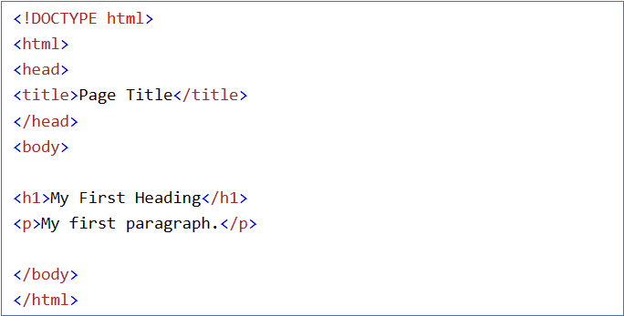

Fig 2.1.2: HTML example

**2.1.3 HTML version timeline**

i.HTML 2 (November 24, 1995)

HTML 2.0 was published as RFC 1866. Supplemental RFCs added capabilities: November 25, 1995: RFC 1867 (form-based file upload)

May 1996: RFC 1942 (tables)

August 1996: RFC 1980 (client-side image maps) January 1997: RFC 2070 (internationalization)

ii.HTML 3 (January 14, 1997)

HTML 3.2 was published as a W3C Recommendation. It was the first version developed and standardized exclusively by the W3C, as the IETF had closed its HTML Working Group on September 12, 1996.

Initially code-named "Wilbur", HTML 3.2 dropped math formulas entirely, reconciled overlap among various proprietary extensions and adopted most of Netscape's visual markup tags. Netscape's blink element and Microsoft's marquee element were omitted due to a mutual agreement between the two companies.

iii.HTML 4 (December 18, 1997)

HTML 4.0 was published as a W3C Recommendation. It offers three variations:

Strict, in which deprecated elements are forbidden,Transitional, in which deprecated elements are allowed, Frameset, in which mostly only frame related elements are allowed.

Initially code-named "Cougar", HTML 4.0 adopted many browser-specific element types and attributes, but also sought to phase out Netscape's visual markup features by marking them as deprecated in favor of style sheets. HTML 4 is an SGML application conforming to ISO 8879 – SGML

iv.HTML 5 (October 28, 2014)

HTML5 was published as a W3C Recommendation. November 1, 2016

HTML 5.1 was published as a W3C Recommendation. December 14, 2017

HTML 5.2 was published as a W3C Recommendation.

**2.2 CSS**

**2.2.1 Introduction to CSS**

Cascading Style Sheets (CSS) is a style sheet language used for describing the presentation of a document written in a markup language such as HTML or XML (including XML dialects such as SVG, MathML or XHTML). CSS is a cornerstone technology of the World Wide Web, alongside HTML and JavaScript.

CSS is designed to enable the separation of content and presentation, including layout, colors, and fonts.This separation can improve content accessibility; provide more flexibility and control in the specification of presentation characteristics; enable multiple web pages to share formatting by specifying the relevant CSS in a separate .css file, which reduces complexity and repetition in the structural content.

**2.2.2 A Simple CSS Document**

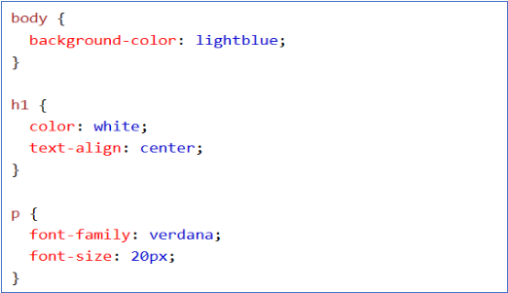

Fig 2.2.2: CSS example

**2.2.3 Syntax**

CSS has a simple syntax and uses a number of English keywords to specify the names of various style properties.

i.Style sheet

A style sheet consists of a list of rules. Each rule or rule-set consists of one or more selectors, and a declaration block.

ii.Selector

In CSS, selectors declare which part of the markup a style applies to by matching tags and attributes in the markup itself. Selectors may apply to the following:

all elements of a specific type, e.g. the second-level headers h2, elements specified by attribute, in particular:

id: an identifier unique within the document, denoted in the selector language by a hash prefix

e.g. #id

class: an identifier that can annotate multiple elements in a document, denoted by a dot prefix

e.g. .classname.

iii.Pseudo-classes

Pseudo-classes are used in CSS selectors to permit formatting based on information that is not contained in the document tree.

One example of a widely used pseudo-class is :hover, which identifies content only when the user "points to" the visible element, usually by holding the mouse cursor over it. It is appended to a selector as in a:hover or #elementid:hover.

iv.Combinators

Multiple simple selectors may be joined using combinators to specify elements by location, element type, id, class, or any combination thereof. The order of the selectors is important. For example, div .myClass {color: red;} applies to all elements of class myClass that are inside div elements, whereas .myClass div {color: red;} applies to all div elements that are inside elements of class myClass.

**2.2.4 CSS version timeline**

v.CSS 1

The first CSS specification to become an official W3C Recommendation is CSS level 1, published on 17 December 1996. Håkon Wium Lie and Bert Bos are credited as the original developers. Among its capabilities are support for: Font properties such as typeface and emphasis, Color of text, backgrounds, and other elements, Text attributes such as spacing between words, letters, and lines of text, Alignment of text, images, tables and other elements.

The W3C no longer maintains the CSS 1 Recommendation.

vi.CSS 2

CSS level 2 specification was developed by the W3C and published as a recommendation in May 1998. A superset of CSS 1, CSS 2 includes a number of new capabilities like absolute, relative, and fixed positioning of elements and z-index, the concept of media types, support for aural style sheets (which were later replaced by the CSS 3 speech modules) and bidirectional text, and new font properties such as shadows.

The W3C no longer maintains the CSS 2 recommendation.

CSS 2.1 was planned as the first and final revision of level 2—but low-priority work on CSS 2.2 began in 2015.

vii.CSS 3

Unlike CSS 2, which is a large single specification defining various features, CSS 3 is divided into several separate documents called "modules". Each module adds new capabilities or extends features defined in CSS 2, preserving backward compatibility. Work on CSS level 3 started around the time of publication of the original CSS 2 recommendation. The earliest CSS 3 drafts were published in June 1999.Due to the modularization, different modules have different stability and statuses.Some modules have Candidate Recommendation (CR) status and are considered moderately stable. At CR stage, implementations are advised to drop vendor prefixes.

viii.CSS 4

Jen Simmons discussing the state of CSS in 2019, as several CSS 4 modules were being advanced.There is no single, integrated CSS4 specification, because the specification has been split into many separate modules which level independently.

Modules that build on things from CSS Level 2 started at Level 3. Some of them have already reached Level 4 or are already approaching Level 5. Other modules that define entirely new functionality, such as Flexbox, have been designated as Level 1 and some of them are approaching Level 2.

**2.3 Javascript**

**2.3.1 Introduction to Javascript**

JavaScript, often abbreviated as JS, is a programming language that is one of the core technologies of the World Wide Web, alongside HTML and CSS. As of 2023, 98.7% of websites use JavaScript on the client side for webpage behavior, often incorporating third-party libraries. All major web browsers have a dedicated JavaScript engine to execute the code on users' devices.

JavaScript is a high-level, often just-in-time compiled language that conforms to the ECMAScript standard. It has dynamic typing, prototype-based object-orientation, and first-class functions. It is multi-paradigm, supporting event-driven, functional, and imperative programming styles. It has application programming interfaces (APIs) for working with text, dates, regular expressions, standard data structures, and the Document Object Model (DOM).

The ECMAScript standard does not include any input/output (I/O), such as networking, storage, or graphics facilities. In practice, the web browser or other runtime system provides JavaScript APIs for I/O.

**2.3.2 A Simple Javascript Document**

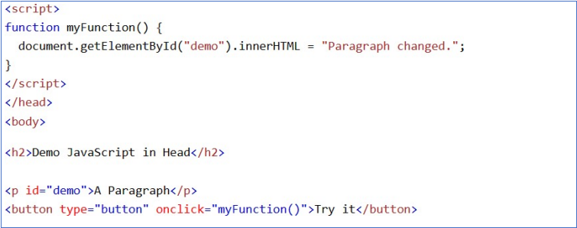

Fig 2.3.2 : Javascript example

**2.3.3 The rise of Javascript**

In November 1996, Netscape submitted JavaScript to Ecma International, as the starting point for a standard specification that all browser vendors could conform to. This led to the official release of the first ECMAScript language specification in June 1997.The standards process continued for a few years, with the release of ECMAScript 2 in June 1998 and ECMAScript 3 in December 1999. Work on ECMAScript 4 began in 2000.

Meanwhile, Microsoft gained an increasingly dominant position in the browser market. By the early 2000s, Internet Explorer's market share reached 95%. This meant that JScript became the de facto standard for client-side scripting on the Web.

Microsoft initially participated in the standards process and implemented some proposals in its JScript language, but eventually it stopped collaborating on Ecma work. Thus ECMAScript 4 was mothballed.

JavaScript is the dominant client-side scripting language of the Web, with 98% of all websites (mid–2022) using it for this purpose. Scripts are embedded in or included from HTML documents and interact with the DOM. All major web browsers have a built- in JavaScript engine that executes the code on the user's device.

Examples of scripted behavior:

* Loading new web page content without reloading the page, via Ajax or a WebSocket. For example, users of social media can send and receive messages without leaving the current page.
* Web page animations, such as fading objects in and out, resizing, and moving them.
* Playing browser games.
* Controlling the playback of streaming media.
* Generating pop-up ads or alert boxes.
* Validating input values of a web form before the data is sent to a web server.
* Logging data about the user's behavior then sending it to a server. The website owner can use this data for analytics, ad tracking, and personalization.
* Redirecting a user to another page.
* Storing and retrieving data on the user's device, via the storage or IndexedDB standards.

JavaScript can be added to HTML file in two ways:

* Internal JS: We can add JavaScript directly to our HTML file by writing the code inside the <script> tag. The <script> tag can either be placed inside the <head> or the <body> tag according to the requirement.
* External JS: We can write JavaScript code in another files having an extension.js and then link this file inside the <head> tag of the HTML file in which we want to add this code.

**2.3.4 Javascript version**

JavaScript is a modern scripting language that is popular worldwide among developers. It is a lightweight, interpreted compiled language that can be used on both client-side as well as the server side. It was invented in the year 1995 by Brendan Eich. Over the years the language has improved a lot and a lot of new features have been added which make the coding process even easier. This language became an ECMA standard in the year 1997.

ECMAScript is the official name of the language. ECMAScript versions have been abbreviated to ES1, ES2, ES3, ES5, and ES6. Since 2016, versions are named by year (ECMAScript 2016, 2017, 2018, 2019, 2020).

**2.4 Bootstrap**

**2.4.1 Introduction to Bootstrap**

Bootstrap is an HTML, CSS and JS library that focuses on simplifying the development of informative web pages (as opposed to web applications). The primary purpose of adding it to a web project is to apply Bootstrap's choices of color, size, font and layout to that project. As such, the primary factor is whether the developers in charge find those choices to their liking. Once added to a project, Bootstrap provides basic style definitions for all HTML elements. The result is a uniform appearance for prose, tables and form elements across web browsers. In addition, developers can take advantage of CSS classes defined in Bootstrap to further customize the appearance of their contents. For example, Bootstrap has provisioned for light- and dark-colored tables, page headings, more prominent pull quotes, and text with a highlight.

**2.4.2 A Simple Bootstrap Document**

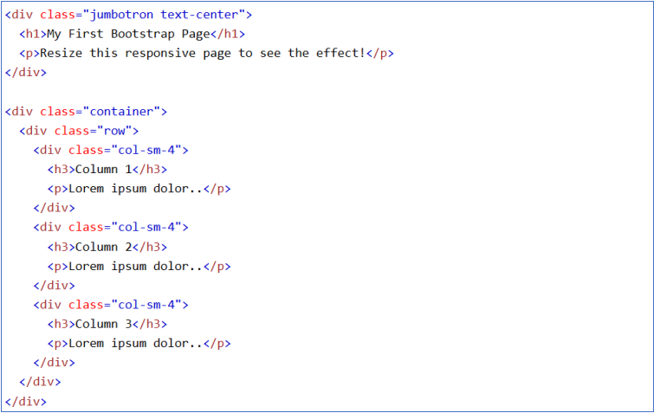

Fig 2.4.2: Bootstrap example

**2.4.3 Features**

Bootstrap is an HTML, CSS and JS library that focuses on simplifying the development of informative web pages (as opposed to web applications). The primary purpose of adding it to a web project is to apply Bootstrap's choices of color, size, font and layout to that project. As such, the primary factor is whether the developers in charge find those choices to their liking. Once added to a project, Bootstrap provides basic style definitions for all HTML elements. The result is a uniform appearance for prose, tables and form elements across web browsers. In addition, developers can take advantage of CSS classes defined in Bootstrap to further customize the appearance of their contents. For example, Bootstrap has provisioned for light- and dark-colored tables, page headings, more prominent pull quotes, and text with a highlight.

Bootstrap also comes with several JavaScript components which do not require other libraries like jQuery. They provide additional user interface elements such as dialog boxes, tooltips, progress bars, navigation drop-downs, and carousels. Each Bootstrap component consists of an HTML structure, CSS declarations, and in some cases accompanying JavaScript code. They also extend the functionality of some existing interface elements, including for example an auto-complete function for input fields.

**2.4.4 Bootstrap versions**

ix.Bootstrap 2

On January 31, 2012, Bootstrap 2 was released, which added built-in support for Glyphicons, several new components, as well as changes to many of the existing components. This version supports responsive web design, meaning the layout of web pages adjusts dynamically, taking into account the characteristics of the device used (whether desktop, tablet, mobile phone).

x.Bootstrap 3

On August 19, 2013, Bootstrap 3, was released. It redesigned components to use flat design and a mobile first approach. Bootstrap 3 features new plugin system with namespaced events. Bootstrap 3 dropped Internet Explorer 7 and Firefox 3.6 support, but there is an optional polyfill for these browsers.

xi.Bootstrap 4

Otto announced Bootstrap 4 on October 29, 2014. The first alpha version of Bootstrap 4 was released on August 19, 2015. The first beta version was released on August 10, 2017. Otto suspended work on Bootstrap 3 on September 6, 2016, to free up time to work on Bootstrap 4. Bootstrap 4 was finalized on January 18, 2018.

xii.Bootstrap 5

Bootstrap 5 was officially released on May 5, 2021.

Major changes include: New offcanvas menu component, Removing dependence on jQuery in favor of vanilla JavaScript, Rewriting the grid to support responsive gutters and columns placed outside of rows, Migrating the documentation from Jekyll to Hugo, Dropping support for Internet Explorer.

**2.5 jQuery**

**2.5.1 Introduction**

jQuery is a JavaScript library designed to simplify HTML DOM tree traversal and manipulation, as well as event handling, CSS animation, and Ajax. It is free, open-source software using the permissive MIT License. As of August 2022, jQuery is used by 77% of the 10 million most popular websites. Web analysis indicates that it is the most widely deployed JavaScript library by a large margin, having at least 3 to 4 times more usage than any other JavaScript library.

jQuery's syntax is designed to make it easier to navigate a document, select DOM elements, create animations, handle events, and develop Ajax applications. jQuery also provides capabilities for developers to create plug-ins on top of the JavaScript library. This enables developers to create abstractions for low-level interaction and animation, advanced effects and high-level, theme-able widgets. The modular approach to the jQuery library allows the creation of powerful dynamic web pages and Web applications.

**2.5.2 A Simple jQuery Document**

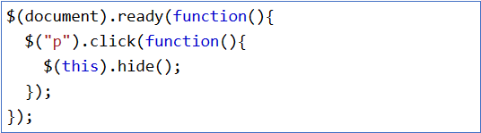

Fig 2.5.2: jQuery example

**2.5.3 Features**

jQuery includes the following features:

DOM element selections using the multi-browser open source selector engine Sizzle, a spin- off of the jQuery project, DOM manipulation based on CSS selectors that uses elements' names and attributes, such as id and class, Events, Effects and animations, Ajax etc.

Some of the key points which support the answer for why to use jQuery:

* It is incredibly popular, which is to say it has a large community of users and a healthy amount of contributors who participate as developers and evangelists.
* It normalizes the differences between web browsers so that you don’t have to.
* It is intentionally a lightweight footprint with a simple yet clever plugin architecture.
* Its repository of plugins is vast and has seen steady growth since jQuery’s release.
* Its API is fully documented, including inline code examples, which in the world of JavaScript libraries is a luxury. Heck, any documentation at all was a luxury for years.
* It is friendly, which is to say it provides helpful ways to avoid conflicts with other JavaScript libraries.

**Chapter - 3**

**Demonstration of technology through project**

**(About the Project)**

**3.1 Introduction**

This project introduces a comprehensive overhaul of the online presence for Vital Vishwa Publications Pvt. Ltd. through the development of a dynamic and visually engaging website. The website is crafted using a combination of HTML, JavaScript, and CSS, employing a Material Design approach to ensure a modern, intuitive, and user-friendly experience.

**3.2 Importance of a Website or Online Presence**

* Global Reach: A website allows organizations to reach a global audience, breaking down geographical barriers and expanding their market beyond local boundaries.
* Accessibility 24/7: Unlike physical stores or offices that have specific operating hours, a website is accessible 24/7. This means potential customers can learn about your products or services and make purchases at any time, increasing the chances of conversions.
* Credibility and Professionalism: A well-designed website gives a professional image and adds credibility to your organization. It serves as a digital storefront, and customers often perceive businesses with an online presence as more legitimate.
* Marketing and Branding: Having a website provides a platform for effective digital marketing. You can showcase your products or services, run online campaigns, and build a brand presence through content marketing, social media integration, and other online strategies.
* Customer Convenience: Customers appreciate the convenience of researching and purchasing products or services online. A website provides a platform for easy navigation, product/service information, and secure online transactions, enhancing the overall customer experience.
* Cost-Effective Advertising: Compared to traditional forms of advertising, online marketing through a website is often more cost-effective. Various online marketing strategies, such as social media marketing and search engine optimization (SEO), can help drive traffic without a significant financial investment.
* Competitive Advantage: Many competitors already have an online presence. To remain competitive, it's important to have a website that not only matches industry standards but also provides a better user experience and more comprehensive information than competitors.
* Data Collection and Analytics: Websites provide valuable data and analytics tools. By analyzing user behavior and preferences, organizations can make informed decisions, refine marketing strategies, and improve the overall effectiveness of their online presence.
* Communication and Customer Support: A website serves as a communication hub where customers can contact the company, ask questions, and receive support. Features like chatbots and contact forms enhance communication and help in building strong customer relationships.
* Adaptation to Changing Consumer Behavior: As more consumers turn to online channels for information and purchases, having an online presence allows organizations to adapt to changing consumer behavior and preferences.

**3.3 Scope**

The project can be improve by adding some more features like implementing chat feature so that multiple user can chat on a specific book to get a legit review from real reader as well as some features like random suggest feature is also can be implemented so that if anyone want some some book to read but he is confused so shuffle feature can automatically suggest a book for them. As AI chatbots like (ChatGPT and Google Bard) are very popular nowadays we can implement those also into the website to get a brief summary about any book available on the website.

**3.4 Demonstration of Technologies**

**3.4.1 HTML**

HTML is used to create the structure of the page. All the containers, sub-containers, buttons etc. are created with it.

File : index.html

Some of the tags used are <body>, <section>, <form>, <input>, <p> etc.

**3.4.2 CSS**

For the styling the webpage to create a better user experience, CSS is used. By linking the CSS file, I was able to style the texts, images and other components of the website.

File : style.css

CSS is applied through three different ways :

i) Tagname : h4, h2 (least preferred) etc.

ii) Classname : .hide, .title, .time etc.

iii) Idname : #outer-container, #container-top etc.

**3.4.3 Javascript**

It is the most important ingredient in designing a webpage. It is used for creating interactive sites, DOM (Document Object Model) manipulation, animated page transitions, data fetching and much more. I have used Accuweather API for fetching the weather conditions as per the users prompt. For that, I created four js files:

1. index.js : Main file which contains all the functionality and is directly linked with index.html. Here all the DOM manipulation is done, changing the current time, date, setting max and min temperature, taking user input, displaying weather.
2. weather1.js : Fetches the location_key for a place using Location API (set by Accuweather) which is required for getting data from further requests
3. weather2.js : Uses the location_key fetched earlier and gets the daily weather of a place from Accuweather Daily Forecast API
4. weather3.js : Uses the location_key fetched earlier and gets the hourly weather of a place from Accuweather Hourly Forecast API

**3.4.4 Bootstrap**

A powerful tool which provides a comprehensive library of website components. All the features help to create an engaging and user-friendly experience. It helped me in styling my page without writing the long syntax i.e. vanilla CSS.

**3.4.5 jQuery**

jQuery selectors allow you to select and manipulate HTML element(s). jQuery selectors are used to "find" (or select) HTML elements based on their name, id, classes, types, attributes, values of attributes and much more. It's based on the existing CSS Selectors, and in addition, it has some custom selectors. All selectors in jQuery start with the dollar sign and parentheses: $(). In jQuery, most DOM events have an equivalent jQuery method. The next step is to define what should happen when the event fires. For this a function is passed to the event.

**3.4.6 Some additional tools**

1. Google fonts: It is a computer font and web font service owned by Google. This includes free and open-source font families, an interactive web directory for browsing the library, and APIs for using the fonts via CSS and Android. There are over thousands of fonts to choose from. Some of the fonts which I used were Roboto, Ubuntu, and Poppins.
2. Font awesome: Font Awesome is the Internet's icon library and toolkit, used by millions of designers, developers, and content creators. It is a font and icon toolkit based on CSS and Less. As of 2023, Font Awesome was used by 30% of sites that use third-party font scripts, placing Font Awesome in second place after Google Fonts. I used it for the search icon and the weather symbols to denote maximum and minimum temperature, day and night remarks etc.

**Chapter - 4**

**Screenshot of the project**



Fig 4.1 Header

Header of front page with logo of the company on top left corner inside the header main div section and the company name “Vital Vishwa Publications” next to it along with the tagline “Nurturing Ideas, Crafting Realities”.

Font used - Oswald from Google Fonts.



Fig 4.2 Navigation Bar

Navigation bar navigating between different pages available on the website like - Home, About us, Courses, Gallery, Shop, Contacts. When you hover the cursor on any item on navbar it'll glow in yellow color and when you click on them it will simply bring you to the corresponding page.



Fig 4.3 Carousel

A carousel on a website refers to a rotating or sliding display of images, content, or other media elements in a sequential manner. It typically appears as a horizontally or vertically scrolling set of panels or slides, often accompanied by navigation controls such as arrows or dots, allowing users to manually or automatically move through the content. Carousels are commonly used on websites to showcase multiple pieces of information or featured items within a limited space, such as on the homepage or product pages. They serve as a dynamic and interactive way to engage users and highlight various aspects of the website's content or offerings.

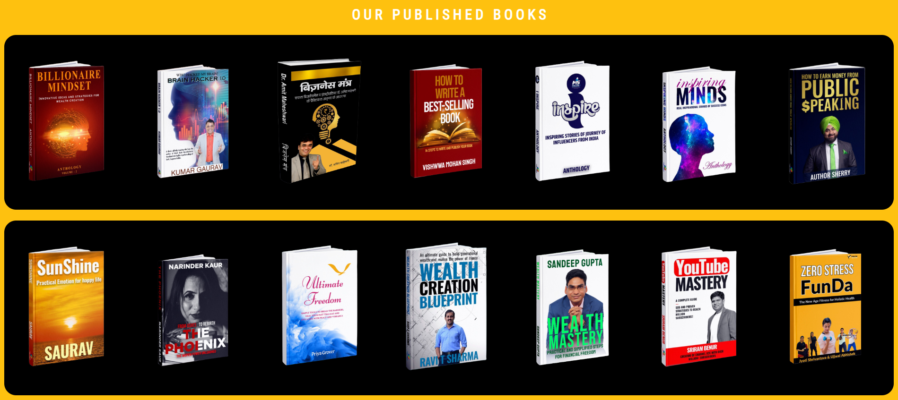

Fig 4.4 Home Body Content Books

Body section of the Home page in which there are two separate div sections to show “Our published books” on the home page. When you hover the cursor over any book showing in any of the div section, the image will zoom in because of the added transition effect using css properties.



Fig 4.5 Footer

The footer which is a fixed and consistent element for all the pages available on the website. It is present at the very bottom of every page that includes social media icons and when you click on them it'll bring you to their social media handles. Also there are some more links like the navigation bar - Home, About us, Courses, Gallery, Shop, Contacts. And at the extreme bottom there is a text containing copyright year along with the name of designers.

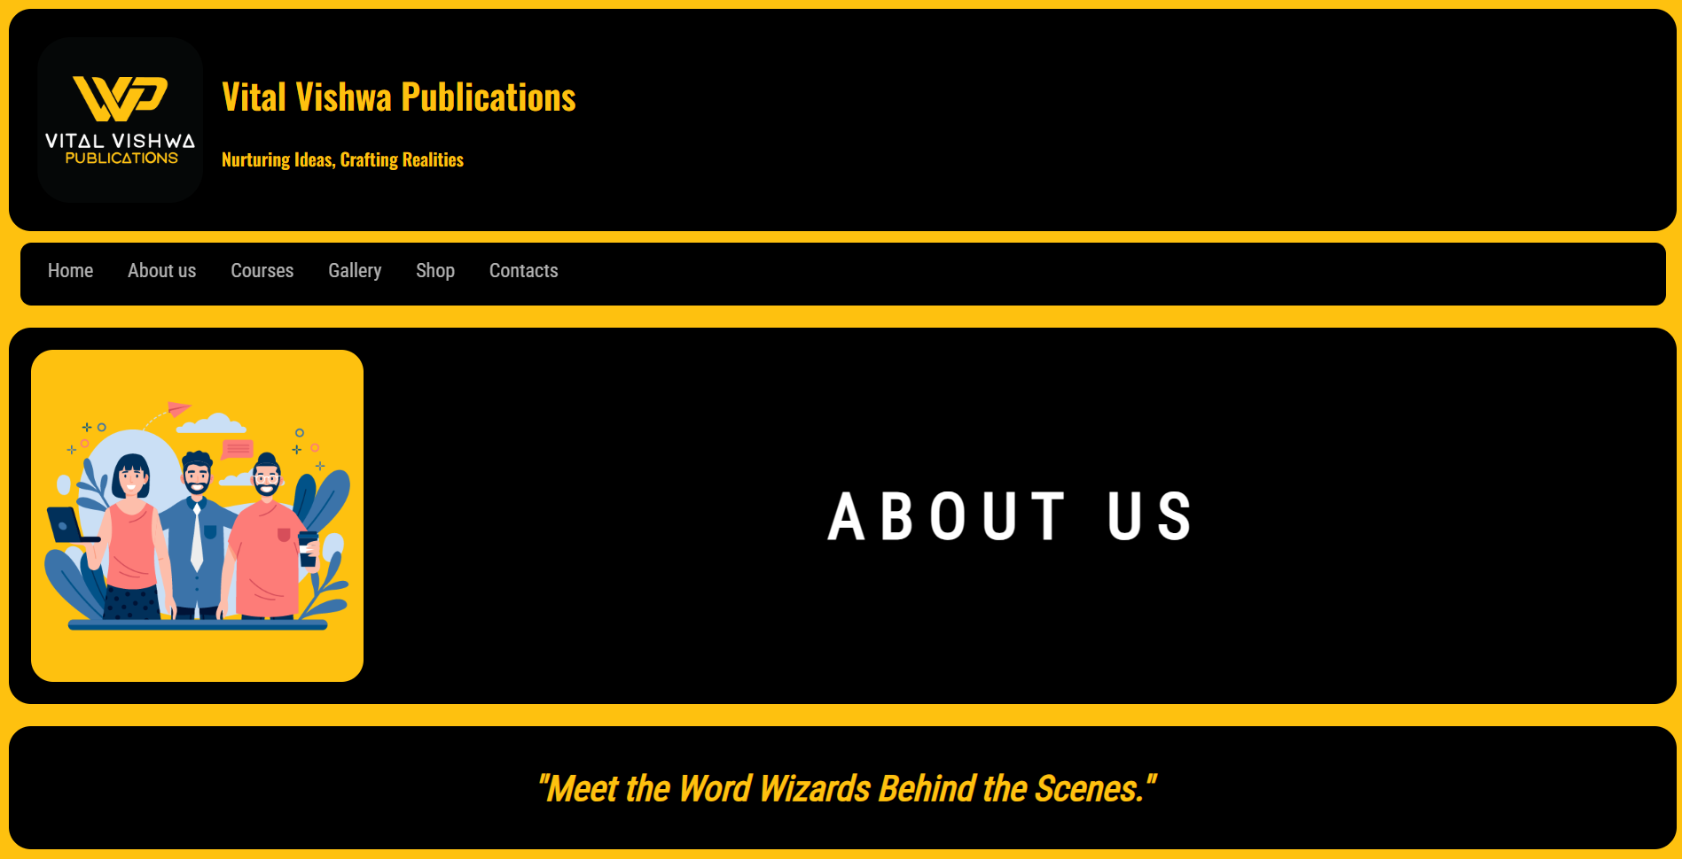

Fig 4.6 About us Header

It's a header section of the About us page in which at the top there is a fixed header and navigation bar same as home page below the navigation bar there is eye-catching vector art which is representing the about us section very beautifully and enhancing the overall material design and aesthetics of the website. Just below the vector art there is a inspiring quote “Meet the Word Wizards Behind the Scene” that's also related to the about us section.

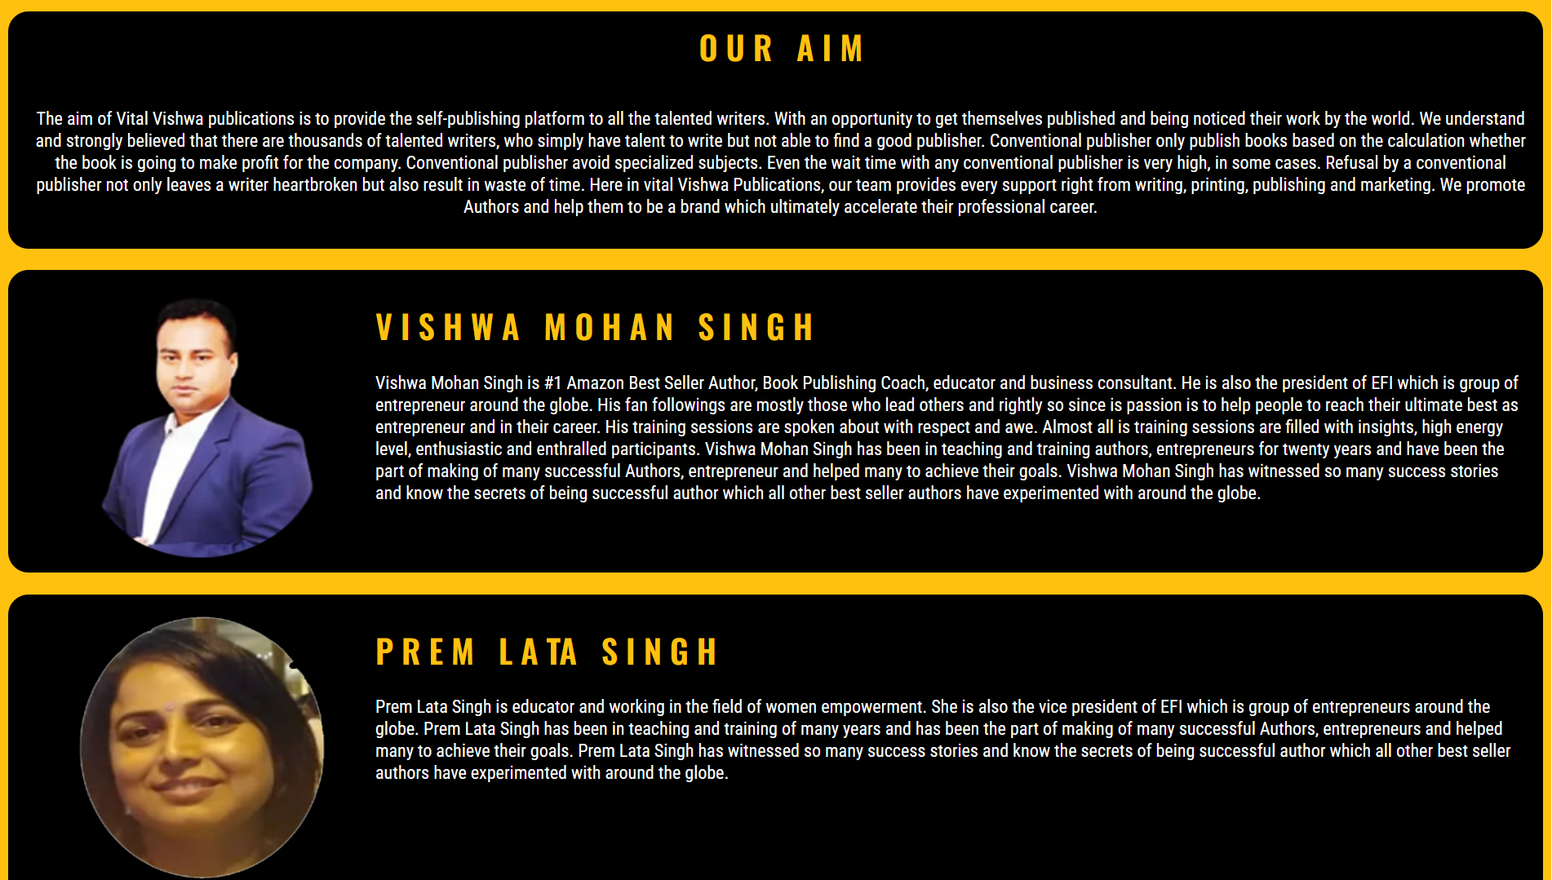

Fig 4..7 About us Body Content

This the main body of about us section, it has three div sections, first section (our aim) includes the information about the aim of the company, second section ( Vishwa Mohan Singh) is all about the CEO of the company with their avatar on the left, third section (Prem Lata Singh) is all about the President of the company.

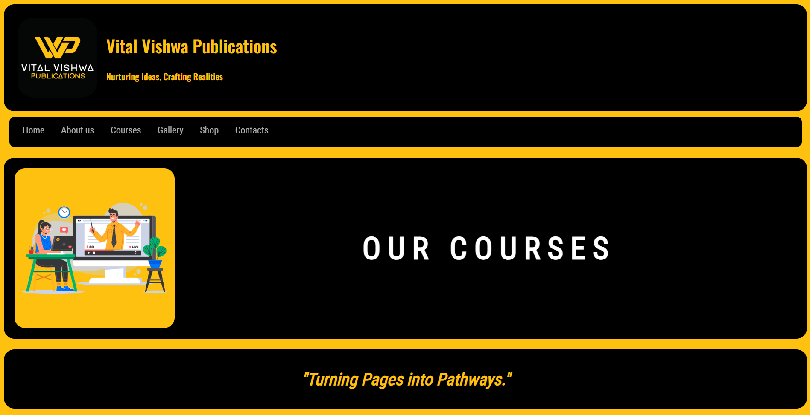

Fig 4.8 Courses Header

It's a header section of the Course page in which at the top there is a fixed header and navigation bar, the same as home page below the navigation bar there is eye-catching vector art which is representing the Courses section very beautifully and enhancing the overall material design and aesthetics of the website. Just below the vector art there is an inspiring quote “Turning Page into Pathways” that's also related to the Courses section.

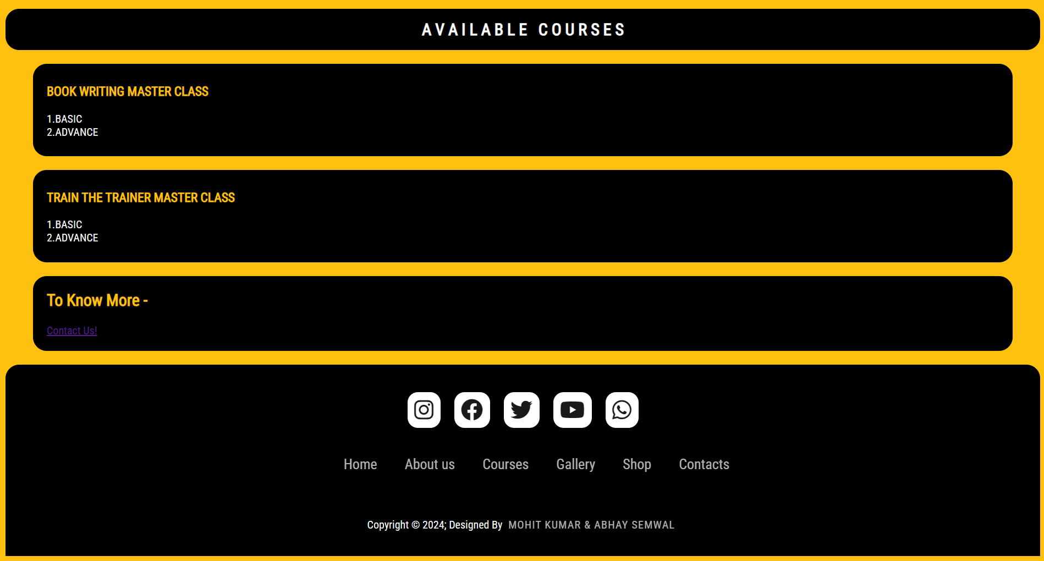

Fig 4.9 Courses Body Content with Footer

This image is a course page body of a webpage. It shows a list of available courses on a black and yellow background. The courses are arranged in two columns, with the course name and a brief description in each column.The image is well-designed and easy to read. The black and yellow background is eye-catching and helps the courses stand out. The text is large and easy to read, and the buttons are clear and easy to understand.

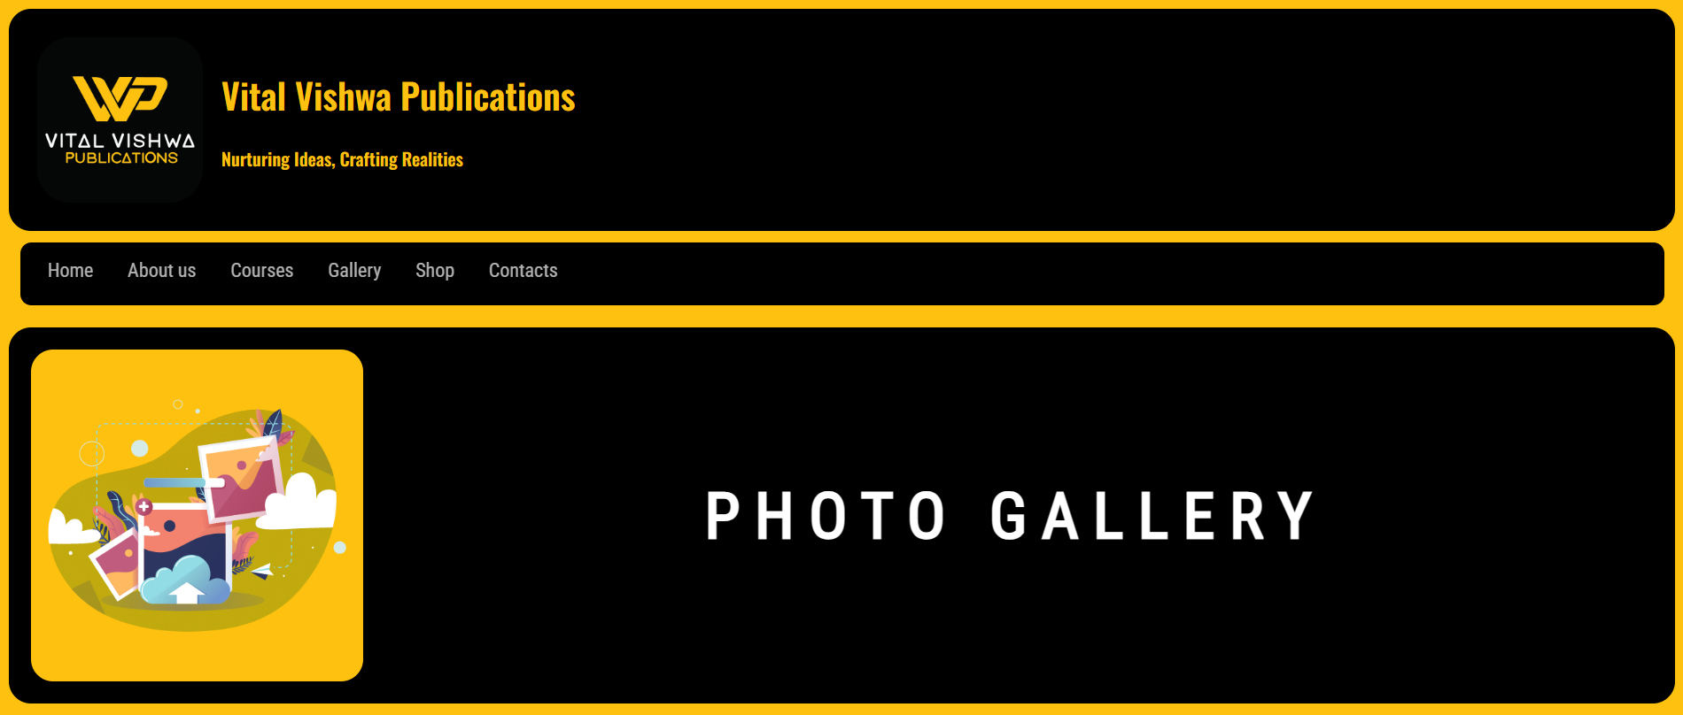

Fig 4.10 Gallery Header

It's a header section of the Gallery page in which at the top there is a fixed header and navigation bar, the same as the home page below the navigation bar there is eye-catching vector art which represents the Gallery section very beautifully and enhances the overall material design and aesthetics of the website.

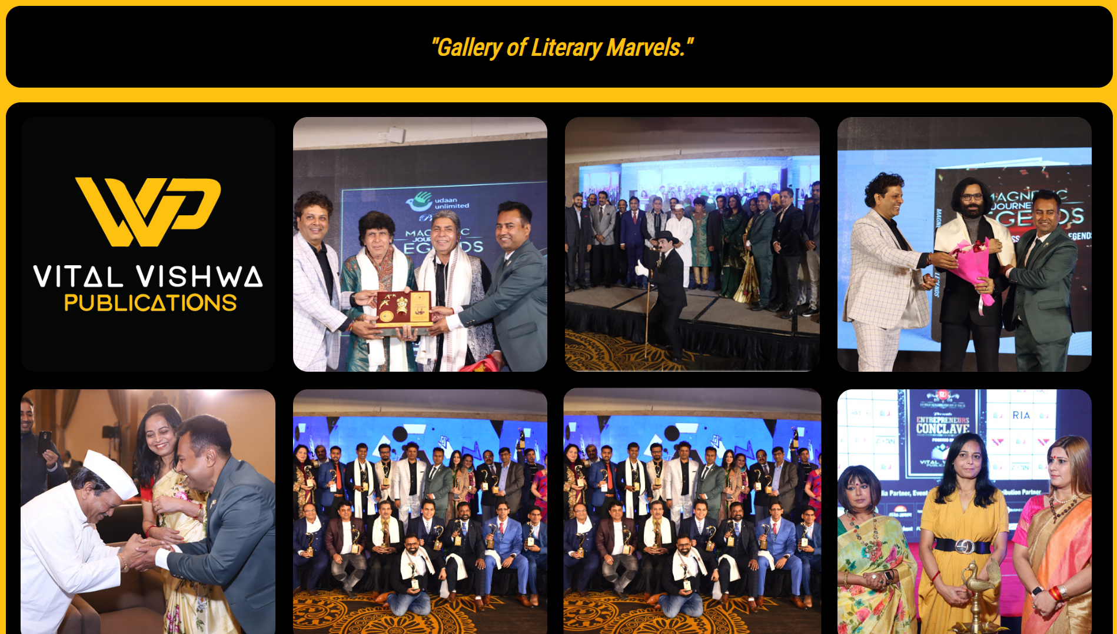

Fig 4.11 Gallery Body Content

It's the main body section of the Gallery page that includes all the images or photos of the events ever happened in the company as well as all the guests and people who are connected to the company.

When you hover the cursor over any image it'll zoom in the image so that you can easily see what is inside the image.

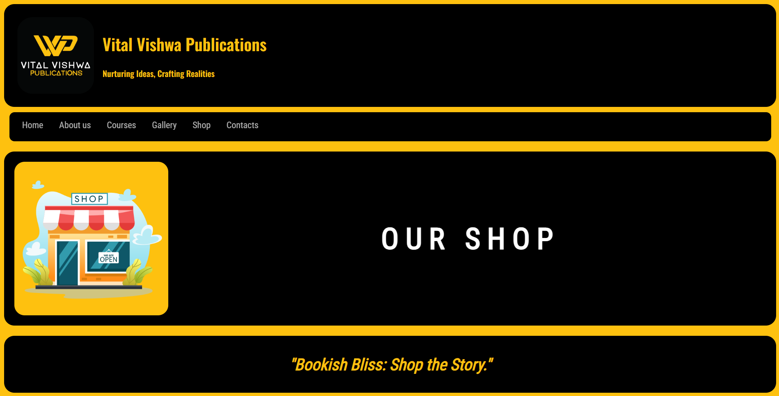

Fig 4.12 Shop Header

It's a header section of the Shop page in which at the top there is a fixed header and navigation bar, the same as home page below the navigation bar there is eye-catching vector art which is representing the Shop section very beautifully and enhancing the overall material design and aesthetics of the website. Just below the vector art there is an inspiring quote “Bookish Bliss: Shop the Story” that's also related to the Shop section.

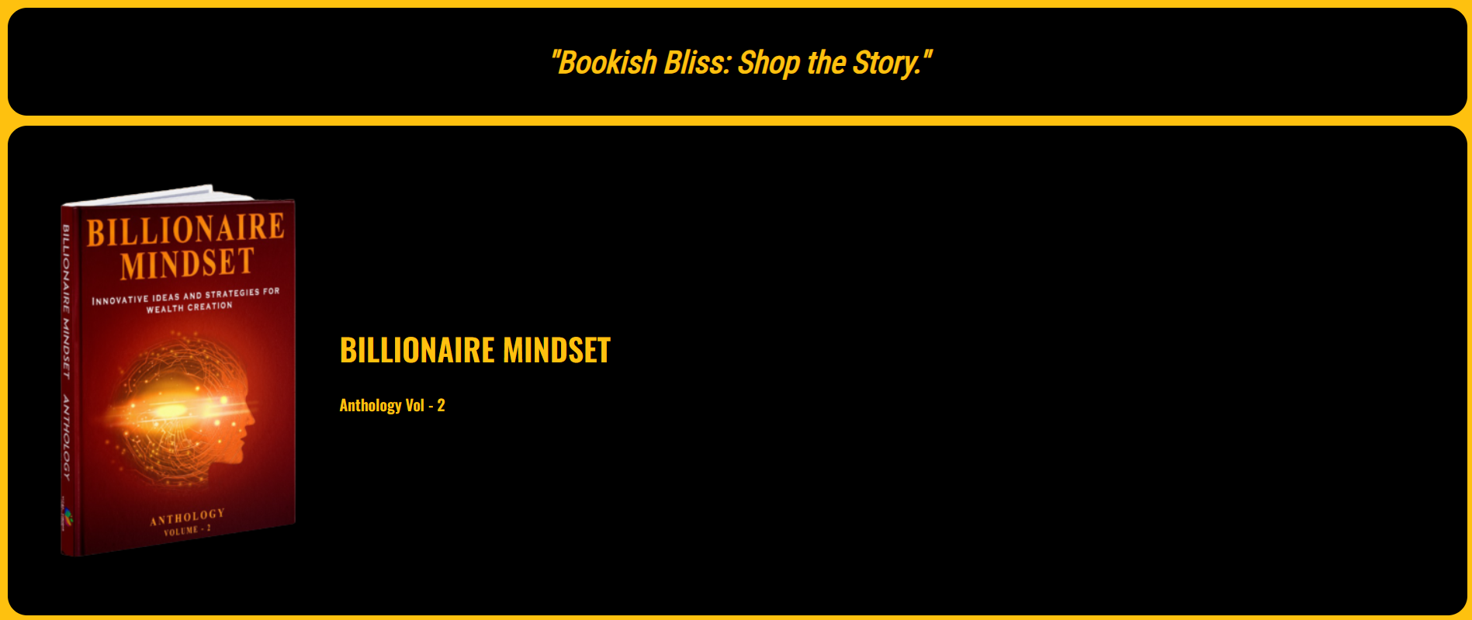

Fig 4.13 Shop Body Element with Quote

It's the body element of shop section in which there are different books and each book have its own div section that includes all the links and details about that book.



Fig 4.14 Shop Body Content End with Next Button

This is the end of shop page body

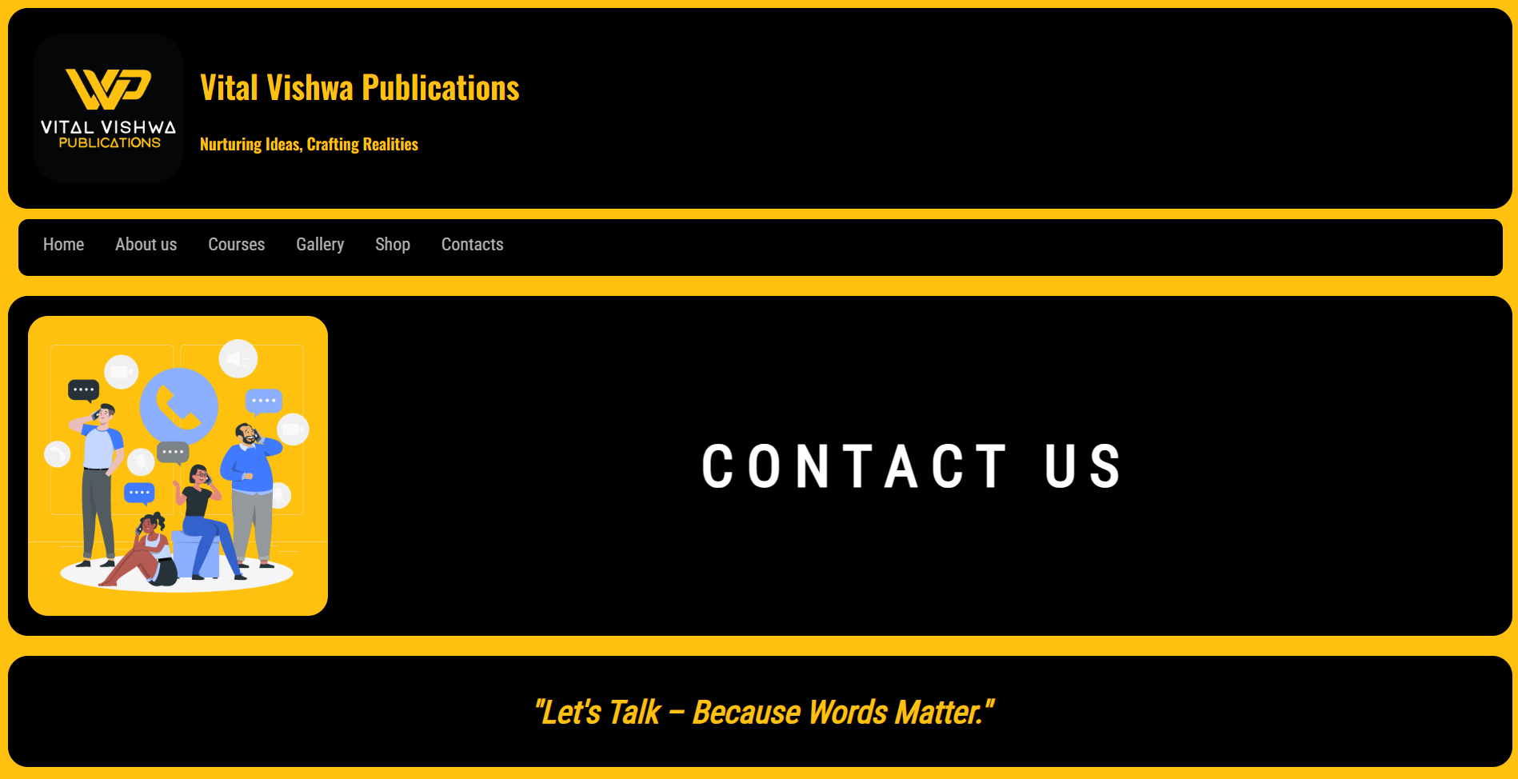

Fig 4.15 Contacts Header

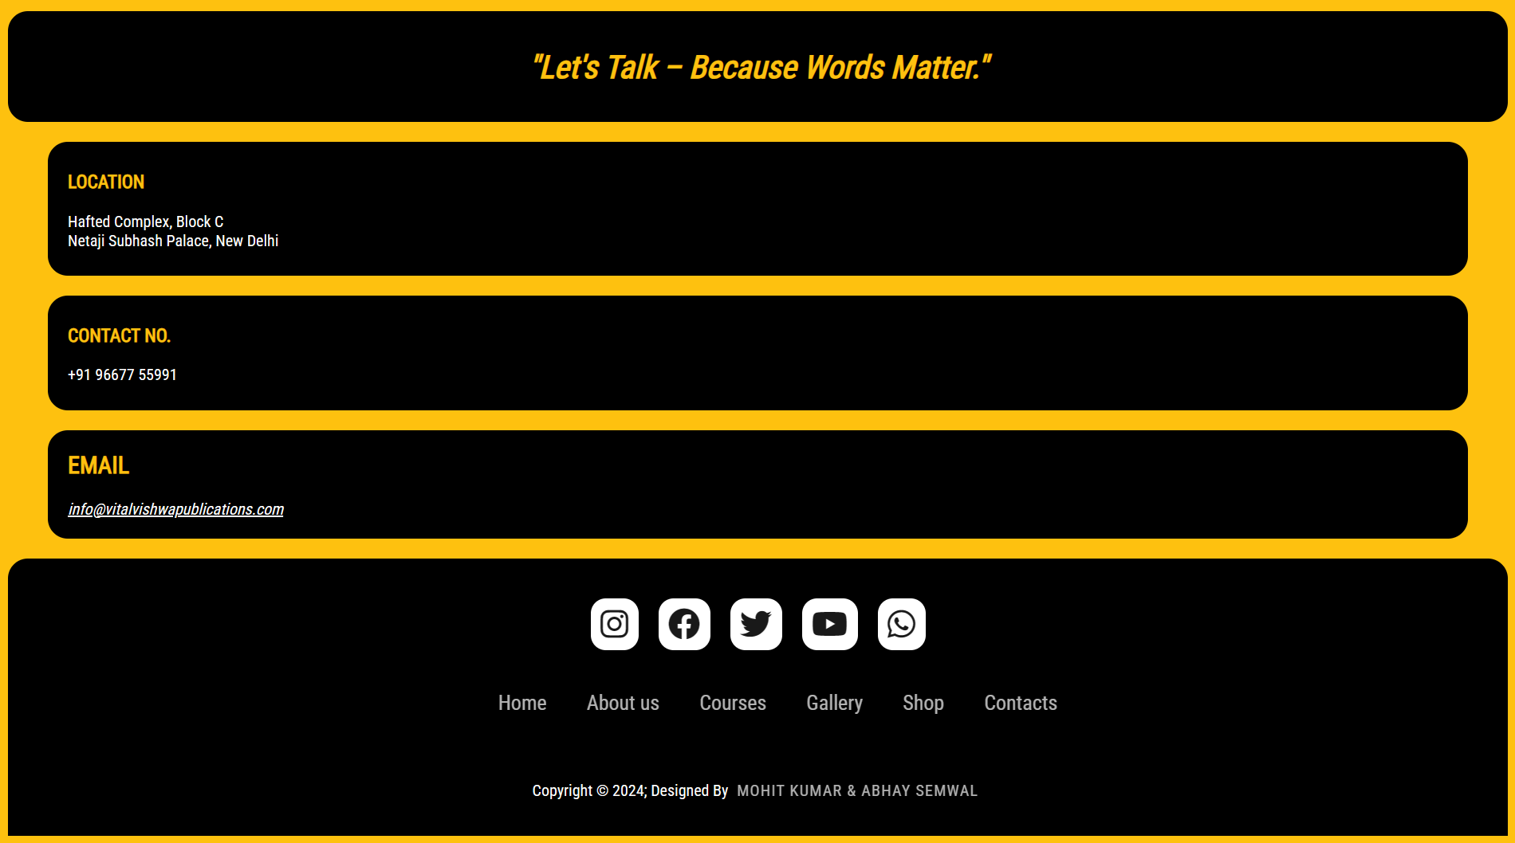

Fig 4.1 Contacts Body Content with Quote and Footer

**Chapter - 5**

**Conclusion**

**5.1 Conclusion**

In conclusion, the development of the Material Design-infused website for Vital Vishwa Publications Pvt. Ltd. marks a significant milestone in modernizing their online presence. The strategic amalgamation of HTML, JavaScript, and CSS has resulted in a dynamic platform that not only showcases the diverse array of publications but also prioritizes a seamless and engaging user experience.

The adoption of Material Design principles played a pivotal role in shaping the website's aesthetic appeal and functionality. The responsive layout ensures accessibility across devices, while intuitive navigation menus and interactive elements crafted with JavaScript enhance user engagement. The commitment to a clean, minimalist design, vibrant color schemes, and subtle animations reflects the contemporary and user-centric approach that aligns with the evolving expectations of today's online audience.

This underscores the importance of a visually appealing and intuitive online presence for businesses in an increasingly digital world. The website serves as a powerful tool for Vital Vishwa Publications Pvt. Ltd. to connect with their audience, showcase their publications, and stay abreast of industry standards.

As we conclude this project, it is evident that the revamped website is not just a technical achievement but a strategic investment in the company's future. By embracing modern design principles and leveraging the capabilities of HTML, JavaScript, and CSS, Vital Vishwa Publications Pvt. Ltd. is well-positioned to thrive in the digital landscape, offering a compelling and user-friendly interface that resonates with its audience and reinforces its commitment to innovation and excellence.

**Bibliography**

1. https://www.w3schools.com/html/default.asp

2. https://www.w3schools.com/css/default.asp

3. https://developer.mozilla.org/en-US/docs/Web/JavaScript

4. https://getbootstrap.com/docs/5.3/getting-started/introduction/

5. https://developer.accuweather.com/apis

6. https://api.jquery.com/

7. https://fonts.google.com/

8. https://fontawesome.com/docs

9.https://www.udemy.com/course/the-complete-web-development-bootcamp

10.https://chat.openai.com/

11.https://bard.google.com/chat